cho các ví dụ thiết kế liên quan áp dụng lý thuyết giới hạn ghi nhớ của George Miller
Ứng dụng lý thuyết giới hạn ghi nhớ của George Miller trong thiết kế
George A. Miller từng đưa ra một lý thuyết rất nổi tiếng vào năm 1956, gọi là “The Magical Number Seven, Plus or Minus Two”.
Ông cho rằng bộ nhớ ngắn hạn của con người chỉ có thể ghi nhớ khoảng 5 đến 9 đơn vị thông tin cùng lúc.
Điều này có nghĩa là nếu bạn phải nhớ quá nhiều thứ cùng một lúc, não sẽ bắt đầu “lag”.
Trong thiết kế giao diện người dùng (UI/UX), hiểu được giới hạn này giúp chúng ta tạo ra trải nghiệm dễ hiểu, dễ dùng và thân thiện hơn.

1. Menu điều hướng (Navigation)
Một trang web hay ứng dụng chỉ nên có tối đa 5–7 mục chính trong thanh menu.
Ví dụ: Trang chủ – Giới thiệu – Dịch vụ – Tin tức – Liên hệ.
Nếu có quá nhiều mục, người dùng sẽ bị rối và không biết nên chọn gì.
Giải pháp là gộp nhóm hoặc tạo menu con.
Điều này giúp người dùng dễ nhớ và dễ định hướng hơn.

2. Biểu mẫu (Form) đăng ký hoặc khảo sát
Nếu một form có quá nhiều ô nhập liệu, người dùng dễ nản.
Cách tốt hơn là chia thành từng bước nhỏ, mỗi bước chỉ khoảng 5–7 trường thông tin.
Ví dụ: Bước 1 – Thông tin cá nhân, Bước 2 – Địa chỉ, Bước 3 – Thanh toán.
Như vậy người dùng sẽ cảm thấy quá trình nhẹ nhàng hơn, dễ hoàn thành hơn.

3. Thanh công cụ (Toolbar) trong ứng dụng di động
Các app phổ biến như Instagram, TikTok hay Facebook chỉ có 5 biểu tượng chính ở thanh dưới.
Những tính năng khác được gom vào phần “More”.
Thiết kế này giúp người dùng không phải ghi nhớ quá nhiều nút, tập trung vào những gì quan trọng nhất.

4. Dashboard hiển thị thông tin
Khi thiết kế bảng điều khiển, chỉ nên hiển thị 6–7 chỉ số chính như doanh thu, số đơn, số khách hàng…
Nếu hiển thị quá nhiều biểu đồ, người dùng sẽ bị quá tải thông tin và khó tìm ra điều quan trọng.
Việc rút gọn giúp họ dễ theo dõi và ra quyết định nhanh hơn.

5. Số điện thoại hoặc mã sản phẩm
Bạn có để ý không, số điện thoại thường được tách thành cụm như 090-123-4567 chứ không viết liền?
Vì bộ não dễ nhớ các nhóm nhỏ hơn là chuỗi dài liên tục.
Đây là ví dụ điển hình cho việc “chunking” – chia nhỏ thông tin thành từng khối để dễ nhớ hơn.

6. Cài đặt trong ứng dụng
Trong phần “Cài đặt” của điện thoại, chỉ có vài mục chính như Wi-Fi, Bluetooth, Âm thanh, Màn hình,…
Các phần nâng cao sẽ nằm trong mục con.
Cách tổ chức này giúp người dùng dễ định hướng và không bị lạc giữa quá nhiều lựa chọn.

7. Slide thuyết trình hoặc infographic
Một slide chỉ nên có tối đa 7 ý chính.
Nếu bạn nhồi nhét quá nhiều chữ, người xem sẽ không nhớ được gì cả.
Chia nội dung thành nhiều slide nhỏ sẽ hiệu quả hơn nhiều.

ID.DX W07 COGNITIVE / DESIGN
- Activity ATM Withdrawal Storyboard
A storyboard visually depicts the user journey for withdrawing money from an ATM.
Frame | Image Description | Description
1 | 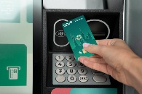  A person walking toward an ATM with a bank card in hand. | User Approaches ATM: Christina walks up to the ATM and takes out her bank card.
2 | 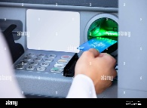  A close-up of the ATM slot as the card is inserted. | Insert Card: Christina inserts her card into the ATM machine.
3 |   A person typing on the keypad; the screen shows the prompt "Enter PIN." | Enter PIN: The screen prompts her for her Personal Identification Number (PIN), and she enters it securely.
4 | 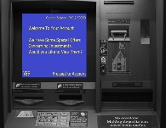  The ATM screen displaying a menu with options like "Withdrawal," "Balance Inquiry," etc. The withdrawal option is highlighted. | Select Transaction: Christina selects the "Withdrawal" option from the main menu.
5 | 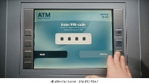  The ATM screen showing a prompt "Enter Amount" with a keypad visible. | Specify Amount: Christina enters the amount she wishes to withdraw (e.g., "$100") and confirms.
6 | 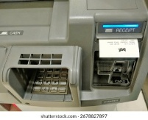  The ATM dispensing cash from the slot and printing a receipt. | Receive Funds: The ATM dispenses the cash and prints the transaction receipt.
7 | 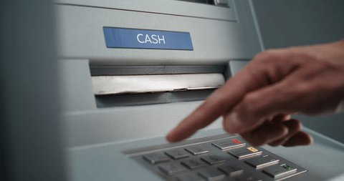  The user taking the bank card from the slot. | Collect Card: Christina takes the cash and receipt, and the ATM returns her card, prompting her to take it.
8 |   The user walking away, checking the contents of their wallet. | Session Complete: Christina confirms she has all items (card, cash, receipt) and walks away.

- Activity ATM User Story Mapping
Based on the principles of User Story Mapping, the ATM experience is broken down into a Backbone (Activities) and detailed Walking Skeleton (User Stories/Tasks).
The Backbone represents the main journey a user takes (the "walk"), and the Stories underneath are the tasks that make up that journey.
Backbone (User Activities - The "Walk") | 1. Authenticate Access | 2. Choose Transaction | 3. Specify Details | 4. Finalize & Receive | 5. End Session
Tasks/User Stories (The Details) | As a user, I can... | As a user, I can... | As a user, I can... | As a user, I can... | As a user, I can...
Priority 1 (Minimum Viable Product - MVP) | Insert my bank card. | See a clear menu of options. | Enter a custom withdrawal amount. | Have the ATM dispense cash. | Have my card returned.
 | Enter my correct PIN. | Select 'Cash Withdrawal'. | Select the checking account. | Be shown my new balance. | See a "Thank You" screen.
Priority 2 (Enhancements) | Be offered a language selection. | Select a quick withdrawal amount (e.g., $20, $40). | Choose to print a receipt. | Be notified if the ATM is low on cash. | Be logged out after inactivity.
 | Get my card back if the PIN fails. | Select 'Balance Inquiry'. | Choose a savings account. | Have the total fees displayed. | Be offered the chance for another transaction.
(The video on User Story Mapping confirms this structure by showing the "Activities" (e.g., Find a product) forming the backbone and "Tasks" (e.g., Browse categories) as the stories below [01:50]).

- Activity New Navigation App Interaction Types
For a new navigation app in a large shopping center, here are tasks best supported by each interaction type:
Interaction Type | Description | Example Tasks Supported by the App
Instructing | Issuing commands to the app. | Find and route: "Navigate to the food court." Search: "Show me all shoe stores."
Conversing | Having a two-way dialogue, often through a chat interface or voice assistant. | Refining search: User: "Find a coffee shop." App: "Which level?" User: "Level 3."
Manipulating | Interacting directly with a digital object (the map) on screen. | Map interaction: Pinch-to-zoom to inspect an area; dragging a 3D model of the building to rotate the view.
Exploring | Moving through an information space to discover new content or locations. | Browsing: Panning across the map to see nearby stores; browsing the directory filtered by "Fashion" or "Electronics."
Responding | The app actively reacts to the user's real-world location or activity. | Navigation alerts: Receiving a haptic buzz and a prompt: "Turn left at the next escalator." Geofencing: A notification pops up: "Welcome to Level 2! Don't miss the sale at Store X."

- Activity Pottery Trade Icons
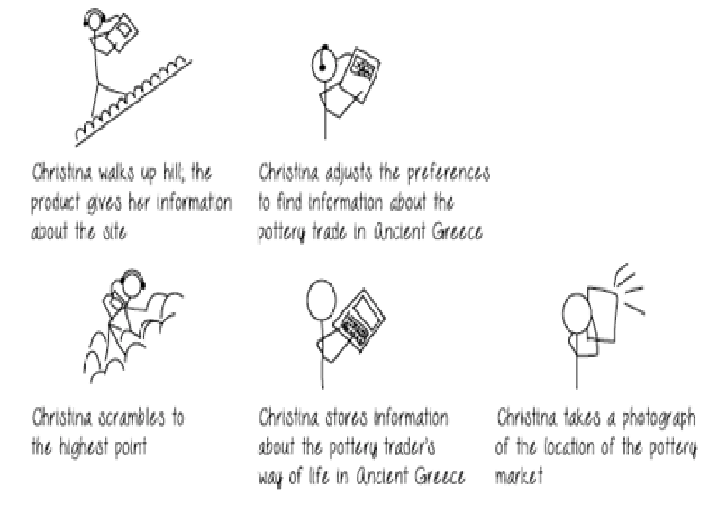
The second scene in the storyboard shows Christina adjusting preferences to find information about the pottery trade in Ancient Greece. Since there is no standard icon for this, here are two alternative suggestions that combine the concepts of pottery/culture and trade/commerce:
Icon Suggestion | Description | Rationale
1. Amphora and Coin |  | This is a literal and direct representation. The Amphora (clay vessel) symbolizes pottery/ancient Greek craft, and the Coin/Stack of Coins symbolizes trade or commerce. It's instantly recognizable as "pottery business/economics."
2. Ship and Vessel | 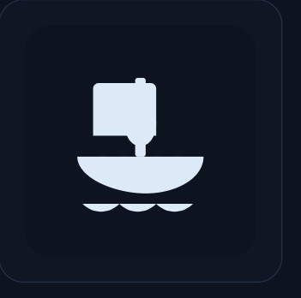 | This represents the historical context of the trade. Ancient Greek pottery was primarily traded across the Mediterranean. The Ship signifies transport and long-distance trade, while the Vessel in the cargo area identifies the product being traded.

- Activity Ticket Booking Product Design

Identify and Capture User Requirements
The primary goal is to design an interactive product for booking event tickets. Based on observing existing systems and user needs, here are key requirements:
Type | Requirement | Rationale
Functional | Interactive Seat Map: Allow users to view and select exact seats on a dynamic map of the venue. | Reduces ambiguity; crucial for users who prioritize view quality or proximity.
Functional | Queueing System: Implement a fair, clear virtual waiting line during high-demand on-sales. | Manages server load and provides a transparent experience when demand exceeds supply.
Non-Functional | Price Transparency: Clearly display a breakdown of the ticket price, service fees, and taxes before checkout. | Builds trust; users are frustrated by hidden fees that appear only at the final step.
Non-Functional | Speed and Performance: The checkout process must be exceptionally fast (under 2 minutes) once seats are selected. | High-demand tickets often have a short holding timer; slow performance leads to lost sales and frustration.
User Data | Wishlist/Alerts: Allow users to save searches or subscribe to alerts for specific artists/venues/dates. | Supports casual planners and dedicated fans; increases repeat visits.
User Profiles, Personas, and Scenarios
User Profile 1: The Dedicated Fan
Persona: Alex "The Early Bird" Chen 🐦
Age: 28
Occupation: Software Developer
Goals: Secure tickets immediately upon release, acquire seats in the first 5 rows (center preferred), and bypass any complex steps to ensure speed.
Frustrations: Virtual queues, slow website load times when an event goes live, and losing tickets while attempting to enter card details.
Quote: "If I don't get the best seats, I don't go."
Main Scenario: High-Demand On-Sale
- Preparation: Alex logs into the app 15 minutes before the event on-sale time and ensures his preferred credit card is set as default.
- Queue: When the clock hits the start time, the app immediately places Alex in a stable virtual queue. The app shows his place in line and the expected wait time.
- Selection: Upon entering the main page, Alex clicks on the Premium Seating filter. He uses the highly responsive, interactive seat map to quickly select two seats in the third row, which are held for him for a guaranteed 5 minutes.
- Checkout: Alex proceeds to checkout. The app uses his pre-saved credit card and shipping address, requiring only a final touch-ID confirmation to process the payment and complete the purchase in under 60 seconds.
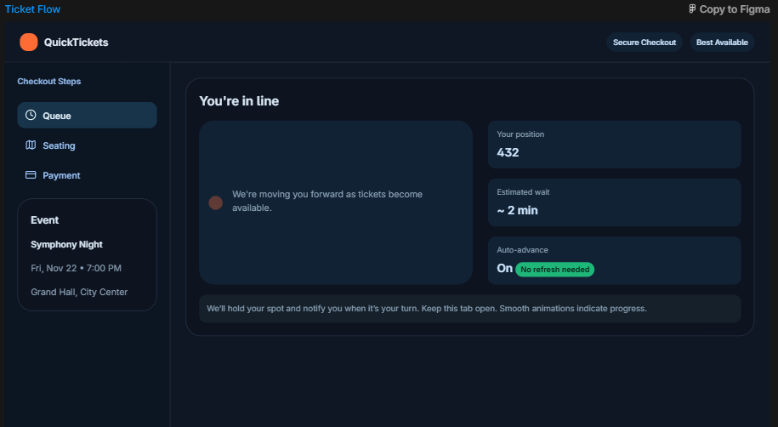
User Profile 2: The Casual Planner
Persona: Maya "The Budget Buyer" Sharma 👨‍👩‍👧‍👦
Age: 45
Occupation: Accountant/Mother of two
Goals: Find a family-friendly event on a weekend, secure four tickets together, and spend no more than $50 per ticket. Needs a simple, guided navigation process.
Frustrations: Confusing website layouts, not knowing the total price until the last page, and discovering that seats are not sequential.
Quote: "I want a fun night out, but the cost needs to be completely clear upfront."
Main Scenario: Weekend Family Outing
- Search & Filter: Maya opens the app and uses the "Filter" function, selecting "Genre: Theatre/Play," "Date: Next 4 Weekends," and "Max Price: $55."
- Discovery: The app shows a list of results. She clicks on a local play, and the product displays a clear "Total Price Estimate" for four tickets based on the average available price range.
- Selection & Verification: Maya selects the ticket package for "Balcony - Row G." The app visually confirms that all four seats are contiguous before allowing her to proceed.
- Transparent Payment: On the checkout page, a side panel clearly itemizes the cost: 4 x Ticket Price ($45) + Service Fees ($10) + Tax ($5) = Total $240. Satisfied with the transparency, Maya enters her credit card information and completes the secure transaction.
